**Objective:** From given specifications, the student will design and build a linear regulated power supply using a full‐wave bridge, variable output voltage, differential error amplifier, adjustable current limiting and adjustable over voltage protection. The design will be soldered to a PCB and must complete the performance stress test.

**References:**

1. **[Checkoff Sheet](https://drive.google.com/file/d/1dVP4FTlOUFsxlAmhoRq_uKyBFUc9YH7r/view?usp=sharing)**
2. **[Transformer Datasheet](https://drive.google.com/file/d/1dXzQiUL2oj7Vc0YjjrJy2lnzfSZpn8fw/view?usp=sharing)**
3. [**Rectifier Diodes Datasheet**](https://drive.google.com/file/d/1d_HqhIZbCGM8WrX5DcnKyvoIllgJsIlb/view?usp=sharing)
4. [**SCR Datasheet**](https://drive.google.com/file/d/1dd9xb9V-lc1wMhtB9Q8IDzjMxD-_92x2/view?usp=sharing)
5. [**PCB Layout**](https://drive.google.com/file/d/1Wk1sVLVrgZLQbrtYND3eT_AhMnaX7i59/view?usp=sharing)
6. [**Heat Sink**](https://drive.google.com/file/d/1detA1s4F7QbiZigJKq0iVWmQKnkpKg-y/view?usp=sharing)
7. [**Heat Sink ver2**](https://drive.google.com/file/d/1deCPOdD9QyaaIRPJDsNQ1iTICh3VT1z6/view?usp=sharing)

**Steps:**

1. Do not build or measure until calculations have been checked-off. Calculated rectifier section. Calculations must include F1 & F2 fuse values and justification, maximum power & current values for D1 – D4, and predicted waveforms.

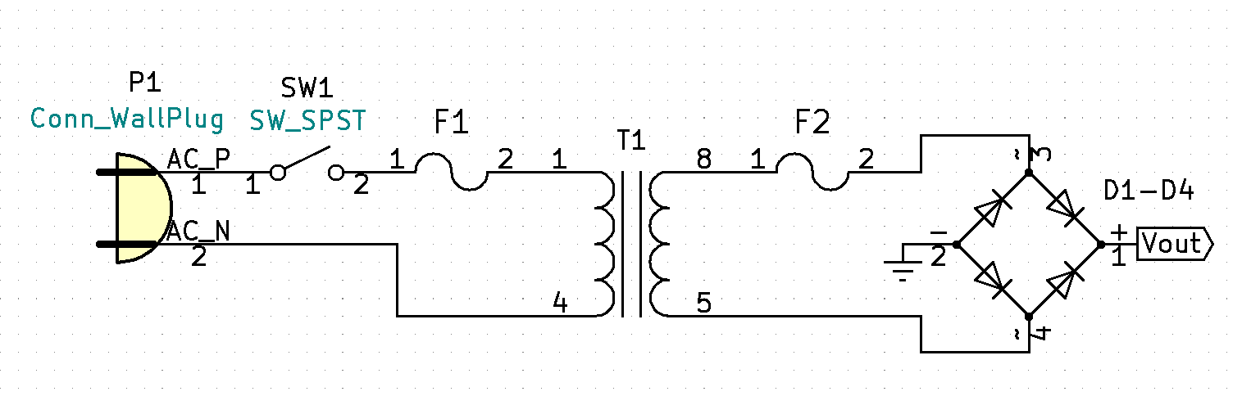

1. Continuity & initial waveform measurements:
   1. Do not plug in power cord to wall outlet. Assemble/solder: Power cord, fuses, on/off switch, transformer, & rectifier. Perform continuity check: with fuses in and the power switch to the on position, use your ohm meter to check continuity between the hot and neutral blades of the power cord, switch the power switch back and forth, set switch to on position and then lift F1, verify that the switch and fuse do break continuity. Next measure continuity from pin 8 to pin 5 on the secondary (if there is no continuity you may have failed to electrically connect pins 6 & 7 via a jumper). Check continuity from pin 8 to point 3 on the rectifier, verify F2 breaks continuity when lifted from its socket. Finally verify continuity of the bridge rectifier.
   2. Be cautious to not get your hand across the AC side of the transformer. When the power plug is plugged in, AC is continuously present at the pcb regardless of switch position. *(when using the Isolation Transformer, do not connect the power cord ground to the circuit, ground will need to be connected after Isolation testing is complete) Use an Isolation Transformer with the ac voltage turned down. Plug in the power cord and slowly bring up the voltage while verifying the output voltage waveform on your oscilloscope. After observing a properly rectified output voltage waveform, you can re-verify operation using wall power.
   3. Measure, verify, and document the unloaded output voltage waveform using wall power. Measure and document the loaded output voltage waveform using wall power (the loaded test should be done incrementally). Start the loaded test by calculating a load resistor that will be approximately 10% of the max current. Make sure to do power calculations and use properly specified resistors. After verifying operation recalculate for 20%, 30%... up to 100% or very near to 100% (do not exceed parts specifications!).

1. Filter Caps
   1. Document calculated filter capacitor values and On/Off indication circuit (use a Green LED).
   2. Assemble filter capacitors and On/Off indication circuit. Verify On/Off circuit. Measure and document unloaded and loaded output voltage waveforms. *(connect power cord ground to the circuit after Isolation load testing is complete)

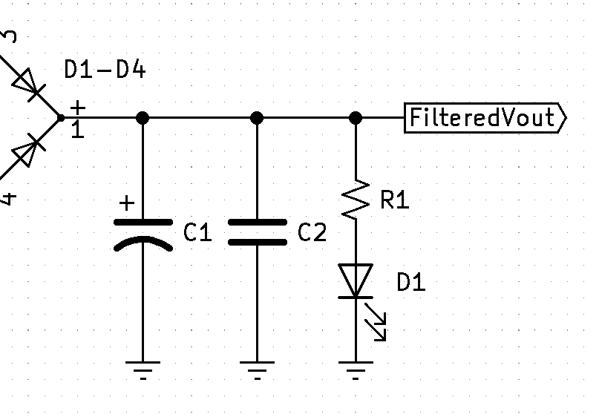

1. 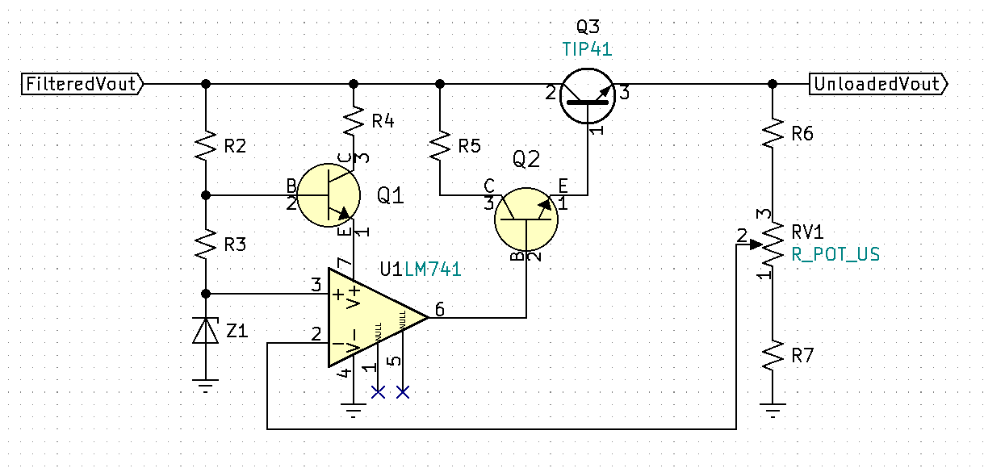Differential Error Amplifier
   1. Calculate and document the op-amp regulated variable voltage section.
   2. Assemble on breadboard. With no load (no RL!) verify variable voltage range.
   3. Assemble on pcb and re-verify operation.
2. Current Limiting/Regulation
   1. Document Q3 heat sink max power calculations. Calculate and document current limiting circuit. Assume the output is shorted and calculate max power of Q3 and R8.
   2. 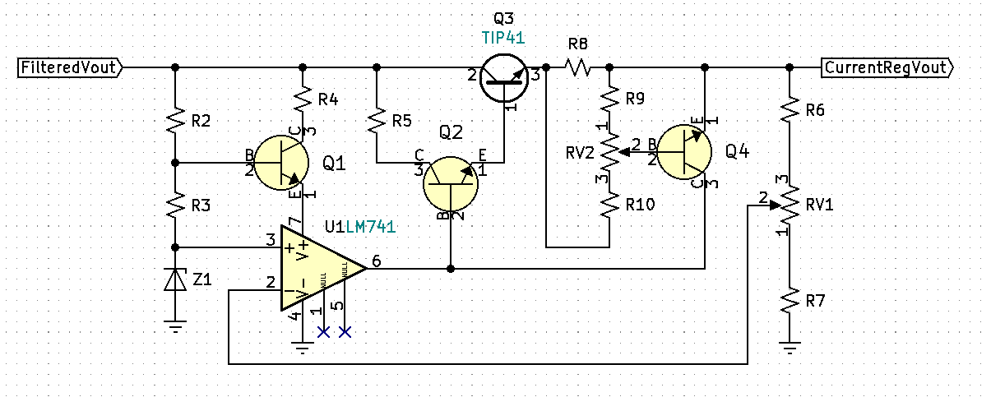Breadboard and verify current-limiting operation by incrementally increase the circuit load until output is shorted through your current meter. Verify current limiting range of operation with shorted output.
   3. Assemble on pcb and re-verify operation.
3. Overvoltage
   1. Calculate and document the over-voltage protection circuit.
   2. 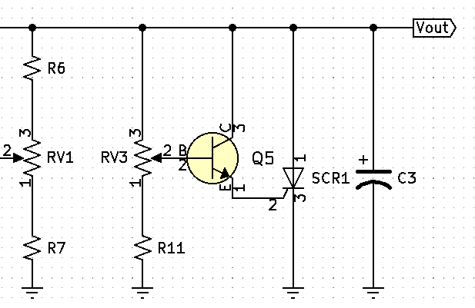Breadboard and verify operation (Step 5 current limiting must be operationally functioning prior to attempting this step!).
   3. Assemble on pcb and re-verify operation.
4. Overvoltage/Output Shorted Indicator
   1. Calculate the Overvoltage/Output Shorted Indicator circuit (use a Red LED).
   2. 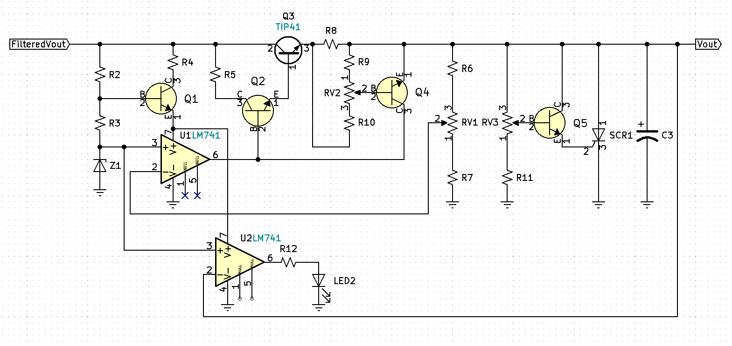Breadboard and verify operation of the Overvoltage/Output Shorted indicator.
   3. Assemble on pcb and re-verify operation.
5. Final Check-Off
   1. Demonstrate that full range of variable voltage, current limiting, and overvoltage meet all minimum requirements.
   2. 60min output shorted stress test.
   3. Re-demonstrate that full range of variable voltage, current limiting, and overvoltage meet all minimum requirements.
   4. Once Final Check-Off is approved, have instructor initial and date the bottom of the power supply and turn in the power supply for grading.
6. BOM (Bill of Materials) Submission
   1. Included an excel spreadsheet with all parts used.
   2. Include part designation, Mouser part#, part description, key specification, part price, and additional comments. See formatting example.
   3. Include Price total (add column E) and Labor hours (number of hours).
   4. Calculate cost of labor hours at 75$/hour.
   5. 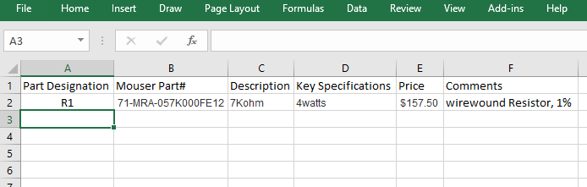Calculate project cost at labor cost plus parts cost.
7. Complete Conclusion and include detailed theory of operations of all circuitry. Document and discuss any discrepancies. Include project cost summary. Submit completed Check-Off sheet and Project Writeup via Moodle.